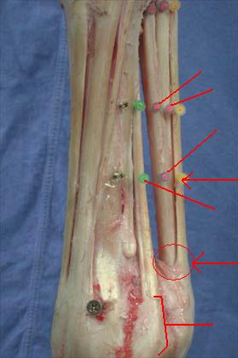
1
2
3
4
5
7
6

- Sheath over the superficial and deep digital flexor tendons has been cut to expose the tendons inside
- Yellow pin: remaining flexor tendon sheath in place
- Pink pin: Superficial digital flexor tendon
- Pink pin: Deep digital flexor tendon
- Pink pin: Collateral ligament crosses from deep over superficial digital flexor tendon, containing superficial
- Green pins: Suspensory ligament (interosseous tendon)
- See bulge where extensor branches of the interosseous move from the sesamoid to join the digital extensor tendon.

